# COMP1003 Maths Worksheet 3

Don’t worry, if you can’t do all of the tasks below. They are just for exercise. You will see (some but perhaps not all) solutions in the Labs or a podcast. The assessment tasks are all easier.

1. Compute the roots of f(x) = x2 -4x + 4 and
2. Compute the derivatives of all orders of f(x) from task 1
3. Compute the integral of f(x) from -1 to 2
4. Multiply the polynomial x2 -4x -4 by 1+x
5. What are the roots/zero crossings of the polynomial from task 4?
6. log10( 1000 ) = ?
7. ld (1024 ) = ?
8. exp( 0 ) = ?
9. exp( 1 ) = ?
10. exp( exp (0) ) = ?
11. ln(e0) = ?
12. Compute the maxima and minima of the funcion in task 1 (if any).
13. Compute the derivative of f(x) = x3 + cos( x3 ) + 1
14. Prove that



1. Compute the integral of exp(ax) for x from 0 to 1.
2. Compute the polar coordinates of the following cartesian points in space

(2,0) , (2, 2) , (-2, 2)

1. Compute all missing angle and sides

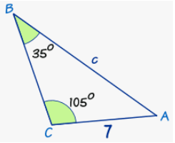

1. Compute all missing angle and sides

